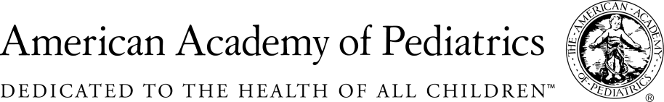
NYSAAP, District II, Chapters 1, 2 & 3

May 9, 2016

NYSAAP, representing more than 5,000 pediatricians across New York State, strongly opposes A.9297.
Implementing universal toxicology testing of all newborns is neither appropriate nor effective in preventing or treating substance abuse among pregnant women. Newborns with NAS (Neonatal Abstinence Syndrome) are currently diagnosed at birth and there are working protocols for the treatment of the baby and education and treatment options for the mother.
This bill proposes testing without an investment in real diagnosis, treatment and educational services. The bill doesn’t recognize that the current technology of toxicology testing of newborns often creates false positives.
But perhaps the deepest problem raised by the proposed legislation is the automatic referral to Child Protective Services.
We strongly oppose this legislation. It is punitive to both baby and Mom and it does nothing to truly address the problem of the small number of children who are born with NAS. Pediatrics has the medical interventions that work now for children born with NAS. They are in use across the state, and in fact, across the nation.
This is bill is not needed, and may indeed produce a further danger to already vulnerable infants by placing them in foster care based on false positive testing rather than true medical diagnosis.
We urge you to reject this legislation.

For More Information Contact:
Elie Ward, MSW
Director of Policy & Advocacy
NYSAAP
eward@aap.net

