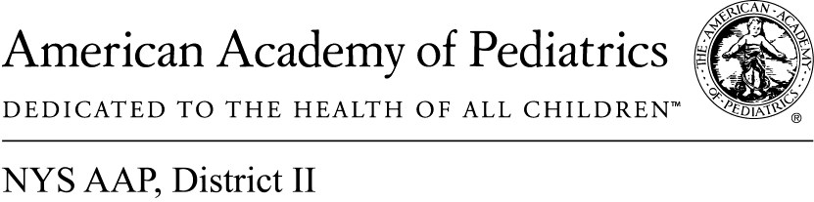
May 12, 2017

Memo of Support A.4472/S.3663

The NYS AAP, representing more than 4,100 pediatricians across New York State, supports A.4472/S.3663 providing legal support for physicians to negotiate with insurers for fair service and reimbursement contracts.

Due to the current imbalance of negotiating power in favor of the managed care plans, physicians are offered take-it-or-leave-it contracts by health plans that can significantly hamper their ability to provide quality patient care. These contracts often permit burdensome processes and unjustifiably long wait times for obtaining pre-authorization to provide needed patient care; impose limitations on whom a physician or other health care provider may refer a patient for necessary care; permit demands for refunds of payments long after the time that such payments were originally made; permit health plans to make major changes to key elements of a contract without physician consent; and cede to physicians and other health care providers the legal consequences for patients harmed by health plan utilization review decisions.

Right now, the playing field in health care contract negotiations strongly favors large managed care plans and disempowers physicians to represent the needs of their patients.

By allowing independent contractor physicians and health care providers to conduct some collective negotiations while being closely monitored by the state, this bill would give physicians greater ability to advocate for patients in contract negotiations. This bill would also create a system under which the state could closely monitor those negotiations, and any negotiations involving fee-related matters would only be permitted when an individual managed care plan controls a substantial share of the managed care market. This legislation would not authorize strikes or boycotts of health benefit plans by physicians.

We fully support A.4472/S.3663 because we believe it will not only help improve health care, it will also create an equitable partnership between health care service providers and large managed care insurers across the state. This legislation will have the ultimate effect of improving patient care and keeping more highly skilled physicians in New York State.

Contact:

Elie Ward, MSW
Director of Policy & Advocacy NYS AAP, eward@aap.net

