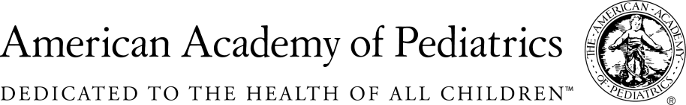
NYSAAP, District II, Chapters 1, 2 & 3

May 15, 2017

Memo of Support
A.1230a

NYS AAP, representing more than 4,000 pediatricians across New York State, strongly supports requiring infants, toddlers and young children in child care settings to be immunized against flu annually.
For most parents getting their children immunized in a timely fashion is something they accept. It is part of anticipated well child visits and immunizations are provided on regular known schedule. And the immunizations are required for child care and school entry.
Flu vaccine is different. First it has to be given every year as the strains of flu change and immunity wanes. Second, flu is and has been a very serious disease for infants and toddlers. Protecting them in congregate care settings where contagion is a real problem is paramount to controlling outbreaks and the spread of disease. And yet, most families still regard flu as a seasonal illness and don’t recognize how potentially dangerous it can be to their very young children.
For the above reasons, we fully support annual flu immunization as a requirement for infant and child care services across the state.
However, regulations implementing this legislation must take into consideration the possibility of vaccine production issues and shortages. Neither pediatricians nor parents should ever be held responsible for problems in the vaccine production pipeline that sometimes lead to shortages of children’s vaccines.

Contact:
Elie Ward, MSW,
Director of Policy & Advocacy, NYSAAP
eward@aap.net.

