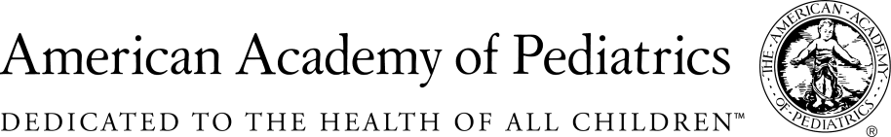
NYSAAP, District II, Chapters 1, 2 & 3

MEMORANDUM OF SUPPORT
A.03899 / S.03941
April 27, 2017
NYSSAAP, representing more than 4,000 pediatricians across New York State, supports A.03899/S.03941 which will provide schools access to student blood lead information in the statewide immunization information system (NYSIIS). Timely access to blood lead information within the school setting is imperative to identify children with lead poisoning and provide them with appropriate educational services. The current state law governing NYSIIS does not provide schools with access to this vital information from the registry. This legislation will address this oversight.
New York State schools need access to student’s BLL data in NYSIIS because:
- LEAD IMPAIRS LEARNING - No safe level of lead has been found; even small amounts of lead exposure can adversely affect health, learning and behavior. Children with a history of lead exposure have a higher risk of developmental delays, IQ loss, ADHD symptoms, auditory processing problems, and learning difficulty than other children.
- EARLY INTERVENTION WORKS - Early educational interventions are crucial to help children overcome the neurocognitive deficits associated with lead exposure.
New York City already provides schools with access to lead levels in their Immunization Registry, CIR. It has improved the earlier identification of children in need of supportive services due to lead’s impact on development and learning. And it is deemed a success by schools and child health community. All schools must adhere to the existing Family Educational Rights and Privacy Act (FERPA) regulations regarding the confidentiality of this and other medical information.
The state, community leaders, parents, health care providers and educators must work together to protect the children of New York State from the harmful effects of lead exposure. Giving schools access to students’ BLL data in NYSIIS will allow schools to focus efforts on assessing children’s educational needs and initiating educational interventions as early as possible.
We urge passage of A.03899 / S.03941

Contact:
Elie Ward, MSW
Director of Policy & Advocacy
NYSAAP, A Coalition of Chapters 1, 2 & 3
eward@aap.net

