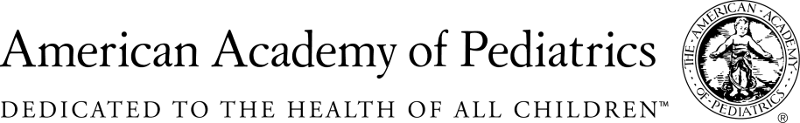
NYSAAP, District II, Chapters 1, 2 & 3
Memo of Support

S.4000
June 5, 2017

The New York State Academy of Pediatrics, NYSAAP, representing more than 4,000 pediatricians across the state, strongly supports S.4000. This bill takes the next step in ensuring that women and families struggling with Maternal Depression can access the treatment they need in a timely manner.
The American Academy of Pediatrics ("AAP") recommends that pediatricians screen mothers for postpartum depression at the 1 month, 2 month and 4 month well-baby visits. Maternal Depression is a significant problem, not only for Moms but for their entire families. Newborns are especially affected by their Mother’s mental health and emotional outlook. Untreated Maternal Depression can and does directly impact a baby’s mental health and social and emotional development.

Despite a significant need, there is a lack of treatment resources for maternal depression in most areas of the state, leaving pediatricians with the onerous task of first screening a Mom and then not being able to find the mental health resources to help her get the treatment she needs.
A centralized list of providers who treat maternal depression, available community resources and peer support groups would help providers conducting screenings to make appropriate referrals and get more women access to treatment.

Additionally, the state must invest in maternal depression treatment resources including strengthening and expanding a statewide hotline, encouraging peer support, and improving the capacity of referral networks.

Contact:

Elie Ward, MSW
Director of Policy & Advocacy
NYSAAP
eward@aap.net

