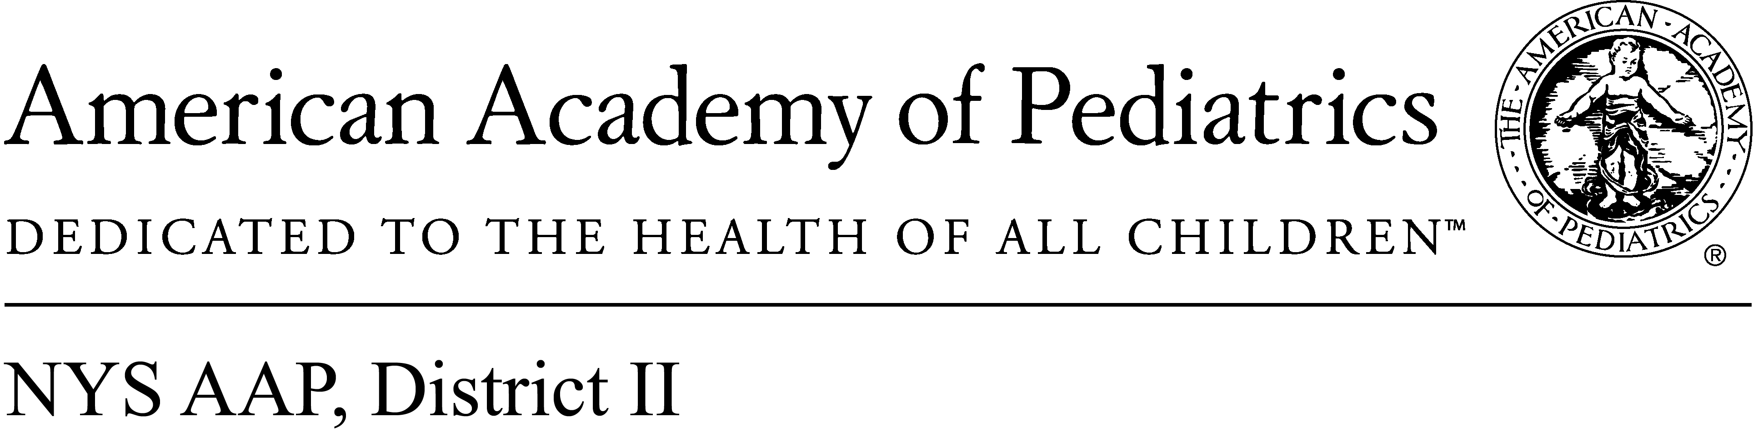
May 22, 2017

Memo of Support
A.6823
The New York State American Academy (NYSAAP) representing more than 4,000 pediatricians across New York, strongly supports A. 6823, legislation that would create the crime of sex trafficking of a child by aligning state law with federal law.
Human trafficking devastates the lives of individuals and destroys families and communities. Children are major targets of human traffickers both because their exploiters find them easier to control than adults and because they are in great demand by sex buyers. Estimates suggest that each year at least 100,000 American children become victims of sex trafficking (National Report on Domestic Minor Sex Trafficking).
While the federal Trafficking Victims Projection Act does not require that prosecutors prove coercion when the victim is a minor, New York State’s anti-trafficking law does. This means that prosecutors cannot build successful cases against child traffickers unless their minor victims are willing and able to testify credibly against those who subjected them to serial rape for profit. The trauma children sustain as a result of sex trafficking and their terror of retaliation against their exploiters often prevents child victims from being credible, willing witnesses. A. 6823 would lift the burden from sex trafficked children of having to provide painful, humiliating details about their sexual exploitation while making it easier for prosecutors to bring strong cases against those who profit from their exploitation. Currently 47 states do not require that prosecutors prove coercion in sex trafficking cases when the victims are minors and thus protect child sex trafficking victims from the trauma of testifying about their degradation and abuse. New York needs to join these other states and offer protection to children who have been sexually exploited for the profit.
A. 6823 recognizes that traffickers sometimes induce young victims to assist them in exploiting other trafficked children. To protect young trafficking victims induced to exploit others, the bill creates an affirmative defense for those ages 19 and younger that the young person was being trafficked within the meaning of federal or state law.
We urge you to support A. 6823 to help protect some of the most vulnerable and exploited children in our state.

Contact:
Elie Ward, MSW
Director of Policy & Advocacy
NYSAAP

