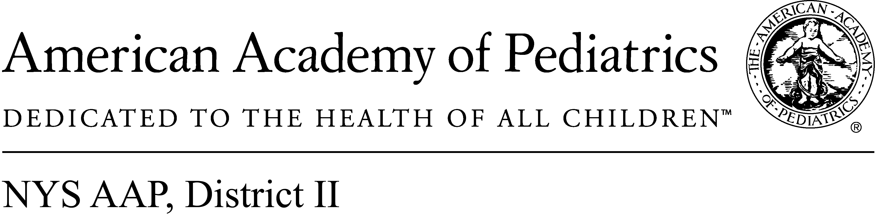
April 28, 2017

Memo of Support
A.6956/S.5433

Tobacco Free Pharmacy Act

The American Academy of Pediatrics, District II, New York State, representing more than 4,000 pediatricians across New York enthusiastically supports A. 6956/S.5433.

This legislation would prohibit pharmacies from selling tobacco products. We fully support any governmental action that will reduce young peoples’ access to tobacco products.

Tobacco is a dangerous and addictive drug that has no positive value. Restricting avenues of purchase and eliminating ease of purchase is good public health policy.

The fact that the CVS Pharmacy chain eliminated tobacco purchase options from all of its locations is a clear indication that their corporate board understood the inherent conflict between being a purveyor of health and health products and selling and harmful and addictive drug.

This legislation would simply carry that same message to other pharmacies who have not yet understood the contradiction and confusion that tobacco sales in a pharmacy that dispenses medicine represent to the general public.

We fully support this legislation and would like to see New York State join other forward looking jurisdictions by prohibiting tobacco sales in pharmacies.

Contact:

Elie Ward
Director of Policy & Advocacy
NYS AAP, District II
eward@aap.net

