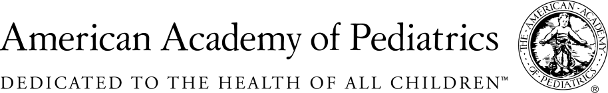
NYSAAP, District II, Chapters 1, 2 & 3

Memo of Support A. 00516/S. 02543
Including E-cigarettes in the Indoor Clean Air Act

January 17, 2017
The NYS American Academy of Pediatrics, representing more than 4,000 pediatricians across NYS, fully supports passage of A. 00516/S.02543.
As pediatricians we have seen a significant and frightening increase in the use of tobacco products with teens using e-cigarettes. E-cigarette usage for middle and high school students tripled in just one year.
We are very concerned about the increase in young smokers. But we are equally concerned with the misconception that “vapor” for e-cigarettes is safe. It is not.
Research has shown that e-cigarette aerosols may include nicotine, acrolein (which is commonly used as a weed killer), the embalming agent formaldehyde and the cancer causing chemical and irritant acetaldehyde. Additionally, some aerosols have been shown to contain harmful carcinogenic metals like cadmium, nickel, and lead. Second hand smoke from e-cigarettes is not safe for anyone, but it is especially dangerous for infant, toddlers and young children.
This legislation would protect the children of New York State from secondhand exposure to nicotine and other potentially harmful chemicals found in these products.
It would also reduce the number of places that e-cigarettes could be smoked, therefore reducing access and acceptability of the e-cigarettes for young people.
New York’s Clean Air Law has proven successful. Including e-cigarettes in this law will make it even more effective. Keeping New York’s children healthy is a bi-partisan priority. Including e-cigarettes in the Clean Indoor Air Act is a step in right direction.

For Additional Information Contact:

Elie Ward, MSW
Director of Policy & Advocacy
NYS American Academy of Pediatrics
eward@aap.net

