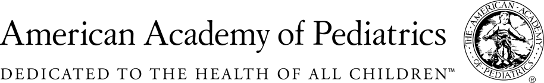
NYSAAP, District II, Chapters 1, 2 & 3
May 29, 2018

Memo of Opposition for A.8123B/S.06141D
Expanded “Religious” Exemption from Immunization
The American Academy of Pediatrics, District II, New York State, representing almost 5,000 pediatricians across the state, strongly opposes A. 8123a/S06141. This bill will expand the ability of parents to claim a “religious” exemption to avoid immunizing their children.
New York State already has religious exemption legislation and a functional regulatory structure. Families who have true religious issues with immunization, can, and do meet the tenets of their religious beliefs within the context of current law. If there are problems with the implementation of the current law and regulation in specific school districts, then those problems should be addressed and resolved.
This bill however, has very little to do with religion. Rather it provides an option for an exemption without clearly stating the decision basis for such an exemption. It is to all extents and purposes a philosophic exemption, since a parent need only state that they are opposed to immunization for “religious” reasons. Every state that has implemented a philosophic exemption has seen a reduction in the percent of children immunized and an increase in outbreaks of preventable disease.
Taken in any other context, this bill would allow a person to say that their “religion” doesn’t allow speed limits therefore they don’t need to obey the speed limit; or their “religion” provides for carrying a concealed weapon at all times and therefore they can do that. And all they would have to do, if this legislation was more broadly applied, is self attest to their “religious” belief re speed limits or concealed weapons.
Civil liberties are an important part of our lives, but civil liberties and social responsibility are always held in balance by the concept of public good. That is why, although we have free speech, we cannot yell “Fire” in a crowded public place, unless, of course, there is a fire.
Universal immunization is a public good. Families who participate in other public goods, such a public school, day care, summer camp, play groups need to take the responsibility to immunize their children so that all children are protected. Immunization works to protect all children through the concept of herd immunity. No vaccination is 100% effective in every child. Protection is afforded through universal immunization which offers protection because most children are immunized, therefore disease cannot spread. If we allow parents who are afraid of vaccination, those who are persuaded by anti-scientific information on the internet, those who believe that somehow vaccines cause all kinds of problems, to decide that their “religion” allows them to reject immunization, then children who are medically fragile and cannot be immunized for medical reasons, or children who are the younger siblings of those in groups and have not yet been immunized will be open to infection. We will allow herd immunization to be breached.
Public and private efforts over the last two decades have resulted in the eradication of most childhood diseases from our state and our country. Parents who chose not to immunize their children have every right to make that decision. But they do not have a right to include that child in public school or group day care, where their lack of immunization has the potential to cause harm to other children.
Here in New York State we have had recent outbreaks of measles, of whooping cough and mumps. Other states have also seen major outbreaks of preventable diseases recently. All of our children are just one plane ride away from infection if we do not assure that all children are appropriately immunized against childhood diseases which in the past have maimed and in fact killed our children.
We are firmly opposed to this insidious and dangerous legislation and urge you to soundly reject it.
Immunization has been one of this country’s greatest public health successes. We cannot allow overconfidence to weaken our children’s safety net and once again have to care for children disabled by measles and polio, and other crippling childhood diseases. The children of New York are depending on you to help keep them safe.

Contact:
Elie Ward, MSW
Director of Policy & Advocacy
eward@aap.net
518-441-4544

