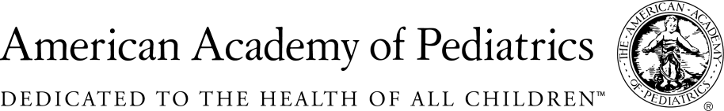
NYSAAP, District II, Chapters 1, 2 & 3

Memo of Support

A.2477/S.2156

March 19,2019

The NYS American Academy of Pediatrics, representing more than 5,000 pediatricians across the state strongly supports A.2477/S.2156 banning the organophosphate pesticide chlorpyrifos.

The organophosphate pesticide chlorpyrifos is part of a class of chemicals developed by Nazi Germany as chemical weapons. It has long been known that exposure to organophosphates can poison people by disrupting the transmission of signals sent between the brain and muscles. Poisoning symptoms range from nausea and vomiting to respiratory paralysis and, in extreme cases, death. Chlorpyrifos remains a leading cause of farmworker poisoning.

In recent decades, it has become clear that even low levels of exposure to chlorpyrifos can harm the developing brains of infants and children. Chlorpyrifos reduces IQ and increases the likelihood of behavioral disorders such as ADHD. These concerns prompted the U.S. Environmental Protection Agency (EPA) to end home use of chlorpyrifos in 2000, though theyallowed other uses to continue.

In November 2015, EPA proposed banning the use of chlorpyrifos on food. The agency’s scientists had reviewed numerous studies and concluded that combined exposure to chlorpyrifos in food and drinking water could poison people. By November 2016, EPA’s scientists had concluded that exposure from food alone could cause brain damage in infants and children. Yet, in March 2017, EPA political appointees disregarded the science and announced that the agency would not finalize the ban. EPA may wait until 2022 to reconsider. Meanwhile, chlorpyrifos exposure continues — and children and farmworkers remain particularly vulnerable to harm.

A coalition of environmental, health, labor, and civil rights organizations has filed a lawsuit challenging EPA’s decision. New York leads a coalition of eight states that have intervened in support of this challenge. In August 2018, a federal appeals court ordered EPA to ban chlorpyrifos, but the agency has appealed further. EPA has not disputed its own scientific findings, instead basing its arguments on procedural issues.

States cannot wait. Last year, Hawaii banned chlorpyrifos. This year, Arizona, California, Connecticut, Maryland, New Jersey, Oregon, and Virginia are considering bans.

By enacting this legislation this year, New York will protect its residents, most especially its children and its farmworkers and send a powerful signal that chlorpyrifos should be banned nationwide.

We urge you to move this legislation quickly through this session. Children in our state are currently at risk of great harm from exposure to chlorpyrifos. We must start now to protect the children and all New Yorkers from this dangerous pesticide.

Contact:

Elie Ward, MSW
Director of Policy & Advocacy
NYS AAP, A Coalition of Chapters 1,2 & 3
eward@aap.net

