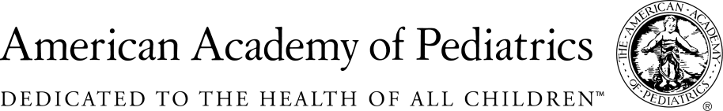
NYSAAP, District II, Chapters 1, 2 & 3
March 11, 2019
Memo of Support for A. 02371/S.2994
Eliminates All But Medical Exemptions for Immunization
The New York State American Academy of Pediatrics representing more than 5,000 pediatricians across the state enthusiastically supports A. 02371/S.2994.
Immunization is a medical intervention which protects infants and young children, as well as adolescents and adults, from preventable disease. As a medical intervention, decisions regarding immunization should be made based on solely medical criteria.
Universal immunization is a public good. Families who participate in other public goods, such a public school, day care, summer camp, play groups need to take the responsibility to immunize their children so that all children are protected. Immunization works to protect all children through the concept of herd immunity. No vaccination is 100% effective in every child. Protection is afforded through universal immunization which offers protection because most children are immunized, therefore disease cannot spread.
If we allow parents who are afraid of vaccination, those who are persuaded by anti-scientific misinformation on the internet, to decide that their “religion” allows them to reject immunization, then children who are medically fragile and cannot be immunized for medical reasons, or children who are the younger siblings of those in groups and have not yet been immunized will be open to infection. We will allow herd immunization to be breached.
Parents who chose not to immunize their children for other than medical reasons have every right to make that decision. But they do not have a right to include that child in public school or group day care, where their lack of immunization has the potential to cause harm to other children.
New York State has had recent outbreaks of measles, of whooping cough and mumps. All of our children are just one plane ride away from infection. We firmly support Medical Exemption only as a reason not to immunize children for school, infant and child care, camp and other children’s group activities.
We cannot allow overconfidence to weaken our children’s safety net and once again have to care for children disabled by measles and polio, and other crippling childhood diseases. The children of New York are depending on you to help keep them safe.
Contact:

Elie Ward, MSW
Director of Policy & Advocacy
NYS AAP, District II, A Coalition of Chapters 1,2& 3
eward@aap.net

