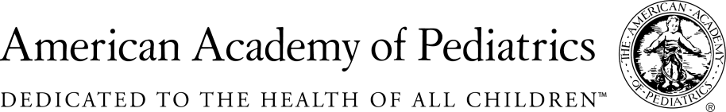
NYSAAP, District II, Chapters 1, 2 & 3

March 11, 2019
Memo of Support for S. 4244

The American Academy of Pediatrics, District II, New York State, representing almost 5,000 pediatricians across the state, strongly supports S. 4244.
This bill, reflecting the “mature minor” concept in health care, will allow young people age 14 and over to consent their own immunizations. New York has long recognized that for decision making in health care, in terms of reproductive health care, mental health, substance abuse and emergency services, often adolescents and young adults have a clearer grasp of what kinds of health care decisions make the most sense for them.
In this instance, which is specific to immunization, young people are often more conscious about the misinformation on the internet and can in many cases disagree with parents who have bought into unfounded and dangerous anti-immunization diatribes and pseudo-science. These young people have a right to protect themselves from diseases that can easily be prevented by immunizations.
We also believe that children have rights, and the many parents who refuse to immunize their children are not protecting their children based on inaccurate and misleading information. Right now in this state who represents the infants and toddlers who are not vaccinated because of parental misinformation. This legislation will allow those 14 and over to make an informed decision for themselves.
We strongly support this bill, and would like to see it passed as soon as possible, so the young people of New York can make their own informed decisions about immunization.

Contact:
Elie Ward, MSW
Director of Policy & Advocacy
NYS AAP, District II, A Coalition of Chapters 1,2& 3
eward@aap.net

