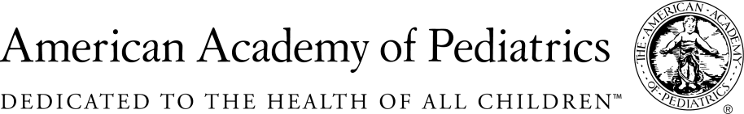
NYSAAP, District II, Chapters 1, 2 & 3

A.6296
March 11, 2019

The NYS American Academy of Pediatrics, representing almost 5,000 pediatricians across the state, strongly supports A.07950/S.06034. Toxic chemicals have no business in children’s products like toys, clothing, or car seats. Yet product makers have reported more than 5,000 types of children’s products that contain dangerous chemicals.

New York must act to protect children’s health with at least the first steps to comprehensive approach as proposed in this legislation.

This legislation proposes New York State require manufacturers to:

- Identify chemicals of high concern based on their inherent hazards;
- Create a priority list of chemicals of high concern found in children’s products;
- Require manufacturers to disclose use of priority chemicals in children’s products;
It is past time New York State moves to protect our children from known toxins in the very products closest to their bodies. Parents and caregivers need to know which products are just not safe to children because they pose chemical risks. A product containing toxic chemicals can rest side by side on a store shelf with one containing only inert materials, and today in New York, the consumer has no way of telling them apart.
Chemicals of high concern to children can be found in jewelry, ceramics, bedding, clothing, toys, accessories, art supplies, and shoes. The National Academy of Sciences finds that 28% of learning and developmental disabilities are attributable to chemicals in the environment. And the science on endocrine disruptor chemicals is clear in terms of multiple significant negative health outcomes.
To save time and cost for product makers and state governments, this bill’s provisions can be met through engagement with the Interstate Chemicals Clearinghouse.
We urge the legislature to pass this bill this year. Let’s begin to protect our children now.

Contact:
ElieWard,MSW
Director of Policy & Advocacy
NYS AAP, District II
eward@aap.net

